**Spring Data JPA - Quick Example** 

**FOLDER STRUCTURE**

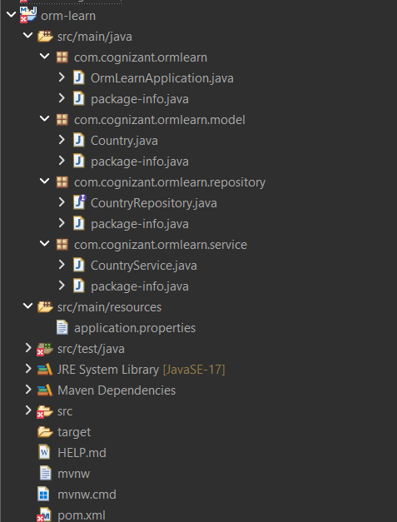

**OrmLearnApplication.java**

package com.cognizant.ormlearn;

import java.util.List;

import org.slf4j.Logger;

import org.slf4j.LoggerFactory;

import org.springframework.boot.SpringApplication;

import org.springframework.boot.autoconfigure.SpringBootApplication;

import org.springframework.context.ApplicationContext;

import com.cognizant.ormlearn.model.Country;

import com.cognizant.ormlearn.service.CountryService;

*@SpringBootApplication*

public class OrmLearnApplication {

private static final Logger ***LOGGER*** = LoggerFactory.*getLogger*(OrmLearnApplication.class);

private static CountryService *countryService*;

public static void main(String[] args) {

ApplicationContext context = SpringApplication.*run*(OrmLearnApplication.class, args);

***LOGGER***.info("Inside main");

*countryService* = context.getBean(CountryService.class);

*countryService*.addSampleData();

*testGetAllCountries*();

}

private static void testGetAllCountries() {

***LOGGER***.info("Start");

List<Country> countries = *countryService*.getAllCountries();

***LOGGER***.debug("countries={}", countries);

***LOGGER***.info("End");

}

}

**Country.java**

package com.cognizant.ormlearn.model;

import jakarta.persistence.Column;

import jakarta.persistence.Entity;

import jakarta.persistence.Id;

import jakarta.persistence.Table;

*@Entity*

*@Table*(name = "country")

public class Country {

*@Id*

*@Column*(name = "code")

private String code;

*@Column*(name = "name")

private String name;

public Country() {}

public Country(String code, String name) {

this.code = code;

this.name = name;

}

public String getCode() {

return code;

}

public void setCode(String code) {

this.code = code;

}

public String getName() {

return name;

}

public void setName(String name) {

this.name = name;

}

*@Override*

public String toString() {

return "Country [code=" + code + ", name=" + name + "]";

}

}

**CountryRepository.java**

package com.cognizant.ormlearn.repository;

import org.springframework.data.jpa.repository.JpaRepository;

import org.springframework.stereotype.Repository;

import com.cognizant.ormlearn.model.Country;

*@Repository*

public interface CountryRepository extends JpaRepository<Country, String> {}

package com.cognizant.ormlearn.service;

import java.util.List;

import org.springframework.beans.factory.annotation.Autowired;

import org.springframework.stereotype.Service;

import org.springframework.transaction.annotation.Transactional;

import com.cognizant.ormlearn.model.Country;

import com.cognizant.ormlearn.repository.CountryRepository;

*@Service*

public class CountryService {

*@Autowired*

private CountryRepository countryRepository;

*@Transactional*

public List<Country> getAllCountries() {

return countryRepository.findAll();

}

*@Transactional*

public void addSampleData() {

countryRepository.save(new Country("IN", "India"));

countryRepository.save(new Country("US", "United States of America"));

}

}

**CountryService.java**

package com.cognizant.ormlearn.service;

import java.util.List;

import org.springframework.beans.factory.annotation.Autowired;

import org.springframework.stereotype.Service;

import org.springframework.transaction.annotation.Transactional;

import com.cognizant.ormlearn.model.Country;

import com.cognizant.ormlearn.repository.CountryRepository;

*@Service*

public class CountryService {

*@Autowired*

private CountryRepository countryRepository;

*@Transactional*

public List<Country> getAllCountries() {

return countryRepository.findAll();

}

*@Transactional*

public void addSampleData() {

countryRepository.save(new Country("IN", "India"));

countryRepository.save(new Country("US", "United States of America"));

}

}

**application.properties**

# Logging

logging.level.org.springframework=info

logging.level.com.cognizant=debug

logging.level.org.hibernate.SQL=trace

logging.level.org.hibernate.type.descriptor.sql=trace

logging.pattern.console=%d{dd-MM-yy} %d{HH:mm:ss.SSS} %-20.20thread %5p %-25.25logger{25} %25M %4L %m%n

# H2 Database Configuration

spring.datasource.url=jdbc:h2:mem:ormlearn

spring.datasource.driver-class-name=org.h2.Driver

spring.datasource.username=sa

spring.datasource.password=

spring.jpa.database-platform=org.hibernate.dialect.H2Dialect

spring.jpa.hibernate.ddl-auto=create-drop

# H2 Console (Optional - for debugging in browser)

spring.h2.console.enabled=true

spring.h2.console.path=/h2-console

spring.datasource.url=jdbc:h2:mem:ormlearn;DB_CLOSE_DELAY=-1;DB_CLOSE_ON_EXIT=FALSE

**pom.xml**

<?xml version="1.0" encoding="UTF-8"?>

<project xmlns="http://maven.apache.org/POM/4.0.0" xmlns:xsi="http://www.w3.org/2001/XMLSchema-instance"

xsi:schemaLocation="http://maven.apache.org/POM/4.0.0 https://maven.apache.org/xsd/maven-4.0.0.xsd">

<modelVersion>4.0.0</modelVersion>

<parent>

<groupId>org.springframework.boot</groupId>

<artifactId>spring-boot-starter-parent</artifactId>

<version>3.5.3</version>

<relativePath/> <!-- lookup parent from repository -->

</parent>

<groupId>com.cognizant</groupId>

<artifactId>orm-learn</artifactId>

<version>0.0.1-SNAPSHOT</version>

<name>orm-learn</name>

<description>Demo project for Spring Data JPA and Hibernate</description>

<url/>

<licenses>

<license/>

</licenses>

<developers>

<developer/>

</developers>

<scm>

<connection/>

<developerConnection/>

<tag/>

<url/>

</scm>

<properties>

<java.version>17</java.version>

</properties>

<dependencies>

<dependency>

<groupId>org.springframework.boot</groupId>

<artifactId>spring-boot-starter-data-jpa</artifactId>

</dependency>

<dependency>

<groupId>com.h2database</groupId>

<artifactId>h2</artifactId>

<scope>runtime</scope>

</dependency>

<dependency>

<groupId>org.springframework.boot</groupId>

<artifactId>spring-boot-starter</artifactId>

</dependency>

<dependency>

<groupId>org.springframework.boot</groupId>

<artifactId>spring-boot-devtools</artifactId>

<scope>runtime</scope>

</dependency>

</dependencies>

<build>

<plugins>

<plugin>

<groupId>org.springframework.boot</groupId>

<artifactId>spring-boot-maven-plugin</artifactId>

</plugin>

</plugins>

</build>

</project>

OUTPUT

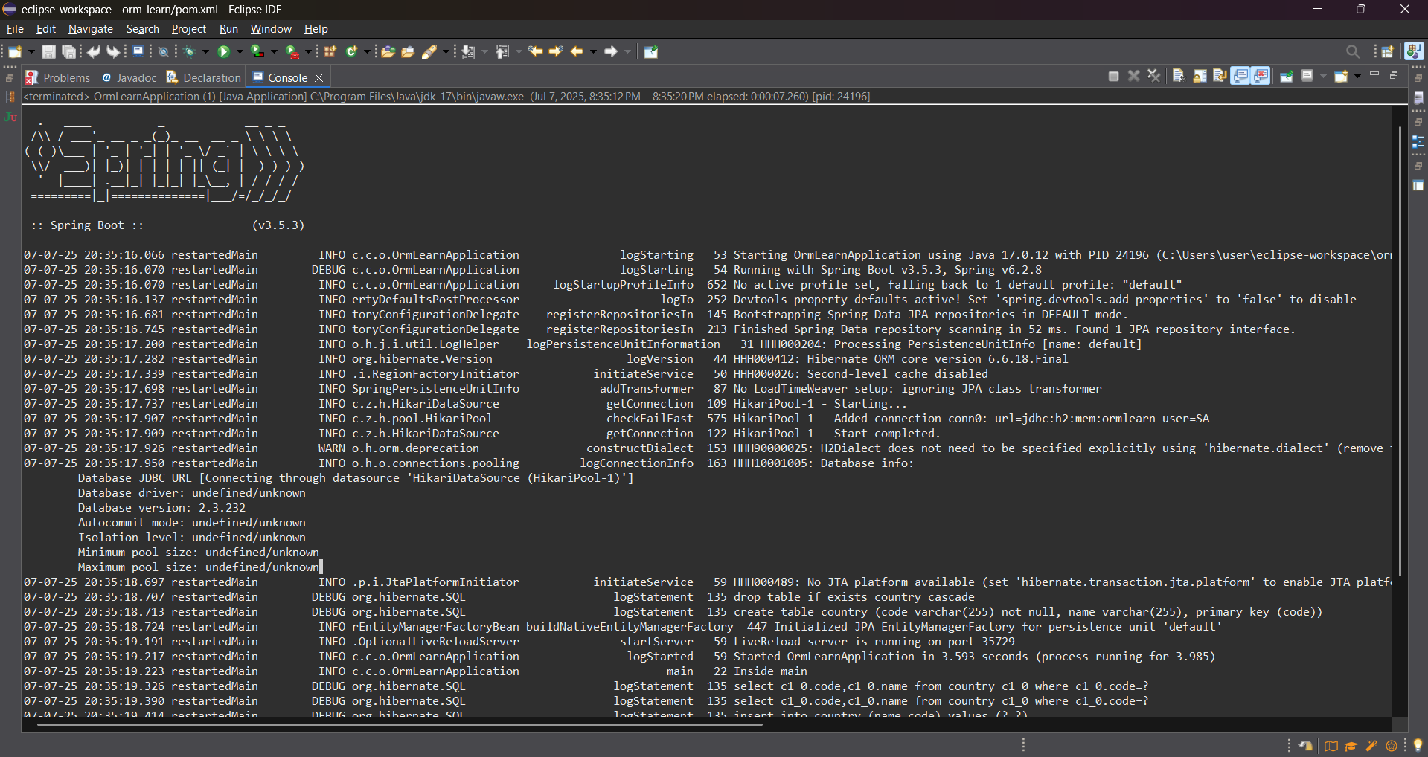

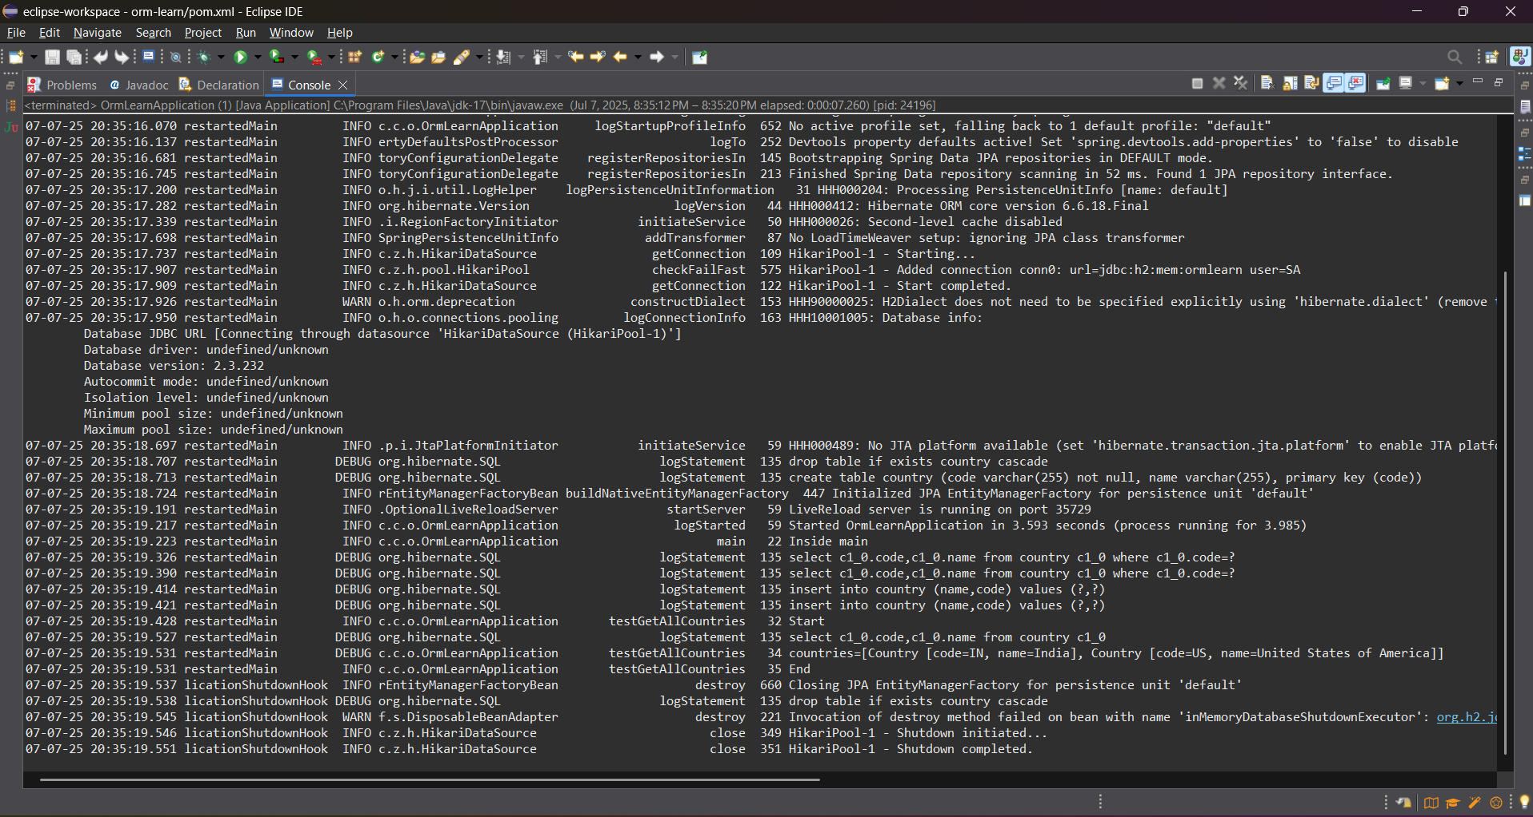

**Difference between JPA, Hibernate and Spring Data JPA** 

**FOLDER STRUCTURE**

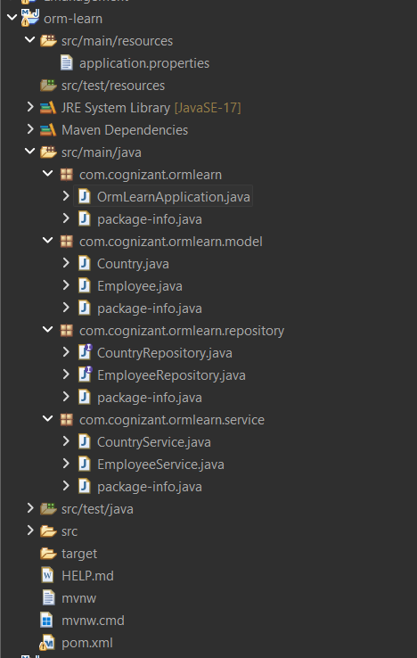

**Employee.java**

package com.cognizant.ormlearn.model;

import jakarta.persistence.Entity;

import jakarta.persistence.Id;

import jakarta.persistence.Table;

*@Entity*

*@Table*(name = "employee")

public class Employee {

*@Id*

private int id;

private String name;

private String department;

public Employee() {}

public Employee(int id, String name, String department) {

this.id = id;

this.name = name;

this.department = department;

}

public int getId() {

return id;

}

public void setId(int id) {

this.id = id;

}

public String getName() {

return name;

}

public void setName(String name) {

this.name = name;

}

public String getDepartment() {

return department;

}

public void setDepartment(String department) {

this.department = department;

}

*@Override*

public String toString() {

return "Employee{id=" + id + ", name='" + name + "', department='" + department + "'}";

}

}

**EmployeeRepository.java**

package com.cognizant.ormlearn.repository;

import com.cognizant.ormlearn.model.Employee;

import org.springframework.data.jpa.repository.JpaRepository;

public interface EmployeeRepository extends JpaRepository<Employee, Integer> {}

**EmployeeService.java**

package com.cognizant.ormlearn.service;

import com.cognizant.ormlearn.model.Employee;

import com.cognizant.ormlearn.repository.EmployeeRepository;

import org.springframework.beans.factory.annotation.Autowired;

import org.springframework.stereotype.Service;

import jakarta.transaction.Transactional;

*@Service*

public class EmployeeService {

*@Autowired*

private EmployeeRepository employeeRepository;

*@Transactional*

public void addEmployee(Employee employee) {

employeeRepository.save(employee);

}

}

**OrmLearnApplication.java**

package com.cognizant.ormlearn;

import com.cognizant.ormlearn.model.Employee;

import com.cognizant.ormlearn.service.EmployeeService;

import org.springframework.beans.factory.annotation.Autowired;

import org.springframework.boot.CommandLineRunner;

import org.springframework.boot.SpringApplication;

import org.springframework.boot.autoconfigure.SpringBootApplication;

*@SpringBootApplication*

public class OrmLearnApplication implements CommandLineRunner {

public static void main(String[] args) {

SpringApplication.*run*(OrmLearnApplication.class, args);

}

*@Autowired*

private EmployeeService employeeService;

*@Override*

public void run(String... args) throws Exception {

Employee emp = new Employee(1, "John Doe", "IT");

employeeService.addEmployee(emp);

System.***out***.println("Employee saved successfully");

}

}

**OUTPUT**

